Hi Engkiat,

Need your to look into the following daily report requirements:

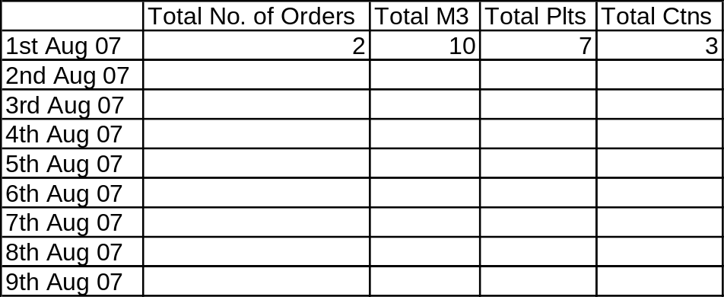

For the above; can we have further breakdown by as follows:

1. Received

2. Shipped

3. On-Hand = At stage, pending ship out

